5.2.2 Properties of the Definite Integral

Properties of the Definite Integral
Theorem: Suppose that f and g are integrable functions on . Then we have that:
- , where c is any constant.
- , where c is any constant.

Note: During class we discussed justifications for each of these results. You need to have these properties memorized, but more importantly you need to develop an understanding of what they say and why each makes sense.

Example 1: Suppose that f is continuous at all real number and that . What is the value of ?

There are several ways of proceeding in answering this question. Here is approach.

Example 2: If it is known that and , find .

By Property 7 we have:

Example 3: Suppose that f is continuous at all real number and that and . What is the value of ?

Theorem (Comparison Properties of the Integral): Suppose that f and g are integrable functions on and m and M are real numbers. Then we have that:

- If for , then .

- If for , then .

- If for , then .

Note: During class we discussed justifications for each of these results. You needs to have these properties memorized, but more importantly you need to develop an understanding of what they say and why each makes sense.

Note: Property 10 is very useful for estimating the value of difficult integrals.
Example 4: Use the properties of integrals to estimate the integral .
When we consider values of x such that and the function we can see that
if
then
and so .
This then implies that which means that .

Therefore, by Property 10 we have that:

Note: This examples helps us begin to answer a question that we posed on the first day of class! As we continue in chapter 5 we will find a way to determine the exact value of this integral.

Example 5: Use the properties of integrals to determine whether the value of is positive or negative.

We first notice that for x-value in the interval and .
Therefore on the interval .
So we can conclude that

Example 6: Evaluate the integral by interpreting it in terms of areas.

We first think about the function .
We may notice that if our function was then it would be the equation of a circle with radius 3.

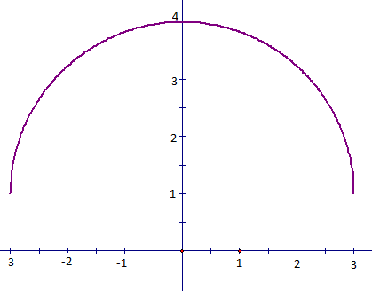  We have the graph of the below. | We can see the area from to is the sum of a rectangle and a quarter of a circle.  

We can compute the two areas and then add them together.

Therefore

